WIPO IP Protection Platform



A Blockchain-Based Digital Intellectual Property Protection System
Arielle-Milan Tchalieu Ngomsi
May 2026

Table of Contents
Table of Contents 2
Table of Figures 8
Project Overview 9
Problem Statement: 9
Project Objectives: 9
Key Features: 9
System Architecture 10
High-Level Architecture: 10
Data Flow: 11
Tools and Technologies Used 12
Frontend: 12
Backend: 12
Database: 12
Security: 12
Blockchain: 12
DevOps: 12
Folder Structure 13
UML Diagrams 18
Use Case Diagram: 18
Class Diagram: 19
Sequence Diagram: 20
Phase 1: Project Setup & Environment 21
Phase 1 Overview: 21
Objectives: 21
Deliverables: 21
Environment Setup: 21
Step 1: Install Prerequisites 21
Step 2: Create Project Directory 22
Backend Setup: 23
Step 1: Create Django Backend 23
Step 2: Create Django Project and Apps 26
Step 3: Configure settings.py (`backend/config/settings.py`) 29
Step 4: Configure urls.py (`backend/config/urls.py`) 29
Frontend Setup: 29
Step 1: Create React + Vite Frontend 29
Step 2: Configure TailwindCSS 31
Step 3: Create Global CSS (`frontend/src/index.css`) 31
Phase 2: Backend Core Development 32
Phase 2 Overview: 32
Objectives: 32
User Authentication: 32
Step 1: Create User Model (`backend/apps/accounts/models.py`) 32
Step 2: Create Admin Configuration (`backend/apps/accounts/admin.py`) 32
Step 3: Create Serializers (`backend/apps/accounts/serializers.py`) 32
Step 4: Create Views (`backend/apps/accounts/views.py`) 33
Step 5: Create URLs (`backend/apps/accounts/urls.py`) 33
Works App (File Upload & Hashing): 33
Step 1: Create DigitalWork Model (`backend/apps/works/models.py`) 33
Step 2: Create Services (SHA-256 Hashing) - `backend/apps/works/services.py` 33
Step 3: Create Serializers (`backend/apps/works/serializers.py`) 34
Step 4: Create Views (`backend/apps/works/views.py`) 34
Step 5: Create URLs (`backend/apps/works/urls.py`) 35
Alerts App (Infringement Detection): 35
Step 1: Create Alert Model (`backend/apps/alerts/models.py`) 35
Step 2: Create Serializers (`backend/apps/alerts/serializers.py`) 35
Step 3: Create Views (`backend/apps/alerts/views.py`) 35
Step 4: Create URLs (`backend/apps/alerts/urls.py`) 35
Phase 3: React Frontend Development 36
Phase 3 Overview: 36
Objectives: 36
API Client and Auth Context: 36
Step 1: Create API Client (`frontend/src/api/client.js`) 36
Step 2: Create Auth Context (`frontend/src/context/AuthContext.jsx`) 36
Authentication Pages: 36
Step 1: Login Page (`frontend/src/pages/Login.jsx`) 36
Step 2: Register Page (`frontend/src/pages/Register.jsx`) 37
Dashboard and Layout: 37
Step 1: Layout Component (`frontend/src/components/Layout.jsx`) 37
Step 2: Dashboard Page (`frontend/src/pages/Dashboard.jsx`) 37
Upload Work Page: 37
`frontend/src/pages/UploadWork.jsx` 37
Phase 4: Blockchain Integration 37
Phase 4 Overview: 37
Objectives: 38
Blockchain Core Implementation: 38
`backend/apps/blockchain/services.py` 38
Blockchain Views and URLs: 38
`backend/apps/blockchain/views.py` 38
`backend/apps/blockchain/urls.py` 39
Blockchain Explorer Frontend: 39
`frontend/src/pages/BlockchainExplorer.jsx` 39
Phase 5: Testing & Quality Assurance 39
Phase 5 Overview: 39
Objectives: 39
Backend Tests: 39
`backend/apps/accounts/tests.py` 39
`backend/apps/blockchain/tests.py` 40
Running Tests: 40
Run all backend tests 40
Run specific app tests 42
Run with coverage report 43
Run frontend tests 46
Phase 6: Additional Features 47
AI Feature Implementation Guide: 47
Adding AI Features 47
Step 1: Install AI Dependencies 47
Step 2: Create Search Feature 48
Create Search Service (`backend/apps/works/search_services.py`) 48
Step 3: Add Search Views (`backend/apps/works/views.py`) 48
Step 4: Update Works URLs (`backend/apps/works/urls.py`) 49
Step 5: Frontend Search Component (`frontend/src/pages/SearchWorks.jsx`) 49
Step 6: Enhanced Infringement Detection with AI (`backend/apps/works/views.py`) 49
Step 7: Update Navigation (`frontend/src/App.jsx`) 49
Phase 7: Azure Deployment 49
Phase 7 Overview: 49
Objectives: 50
Azure Deployment Script: 50
`deploy-azure.ps1` 50
Save credentials to file 55
Deployment Steps: 56
Step 1: Prepare backend for production 56
Step 2: Run deployment script 56
Step 3: Verify deployment 56
Step 4: Create admin user on production 56
API Documentation 57
Authentication Endpoints: 57
Works Endpoints: 57
Alerts Endpoints: 57
Blockchain Endpoints: 57
Example API Calls: 58
Register User 58
Login 58
Get Dashboard Stats 58
Verify Blockchain 58
Challenges & Solutions 59
Challenge 1: Installing Pillow (Backend Setup) 59
Problem: 59
Solution: 59
Challenge 2: Installing Tailwindcss (Frontend Setup) 60
Problem: 60
Solution: 60
Challenge 3: Problem installing npm test (Frontend) 60
Problem: 60
Solution: 61
Challenge 4: Run Frontend Tests 61
Problem: 61
Solution: 62
Conclusion 62
Project Summary: 62
Skills Demonstrated: 63
Technical Skills 63
Soft Skills 63
Future Enhancements: 63
References 63
Tools & Libraries: 63
Backend Dependencies 63
Frontend Dependencies 64
Appendices 64
Appendix A: Quick Reference Commands 64
Start Backend: 64
Start Frontend: 64
Create Migrations: 64
Create Superuser: 65
Run Tests: 65
Deploy to Azure: 65
Appendix B: Environment Variables 65
Backend (.env): 65
Frontend (.env): 65

Table of Figures
Figure 1: High-Level Architecture Diagram 8
Figure 2: Data Flow Diagram 9
Figure 3: Use Case Diagram 15
Figure 4: Class Diagram (Core Models) 16
Figure 5: Sequence Diagram (Upload Work with Blockchain) 17
Figure 6: Installation Verification 18
Figure 7: Create the project directory 20
Figure 8: Create the django backend 23
Figure 9: Create the django project and apps 25
Figure 10: Create React + Vite Frontend 28
Figure 11: Install the AI dependencies 45

Project Overview
The WIPO IP Protection Platform is a comprehensive web-based solution that enables creators, startups, and innovators to protect their intellectual property through digital timestamping using SHA-256 hashing, blockchain verification for immutable ownership records, and automated infringement detection. The platform provides an accessible, secure, and verifiable way to prove ownership of digital works.

Problem Statement:
Digital creators face significant challenges in protecting their intellectual property:
Problem: | Impact: | Current Solution Gap:
Expensive IP registration | Most creators can't afford | Traditional methods cost $500+
Difficulty proving ownership | Works are easily copied | No cheap timestamping available
No automated infringement detection | Creators unaware of copies | Manual searching is impossible
Complex technical requirements | Non-technical users excluded | Most solutions require coding

Project Objectives:
Objective: | Description: | Success Metric:
Digital Timestamping | Provide SHA-256 proof of creation. | Hash generation < 5 seconds.
Ownership Tracking | Blockchain-based ownership records. | Immutable verification.
Infringement Detection | Automatic duplicate content alerts. | Real-time detection.
User Accessibility | Intuitive web interface. | < 3 clicks to upload.
Cloud Deployment | Scalable 24/7 hosting. | 99.9% uptime.

Key Features:
Feature: | Technology: | Description:
JWT Authentication | SimpleJWT | Secure user login/registration.
SHA-256 Hashing | hashlib | Cryptographic file fingerprinting.
Blockchain Ledger | Custom Python | Immutable record of all registrations.
Infringement Alerts | Hash matching | Automatic duplicate detection.
React Dashboard | Vite + Tailwind | Modern responsive UI.
File Storage | Django Media | Secure file uploads.

System Architecture

High-Level Architecture:
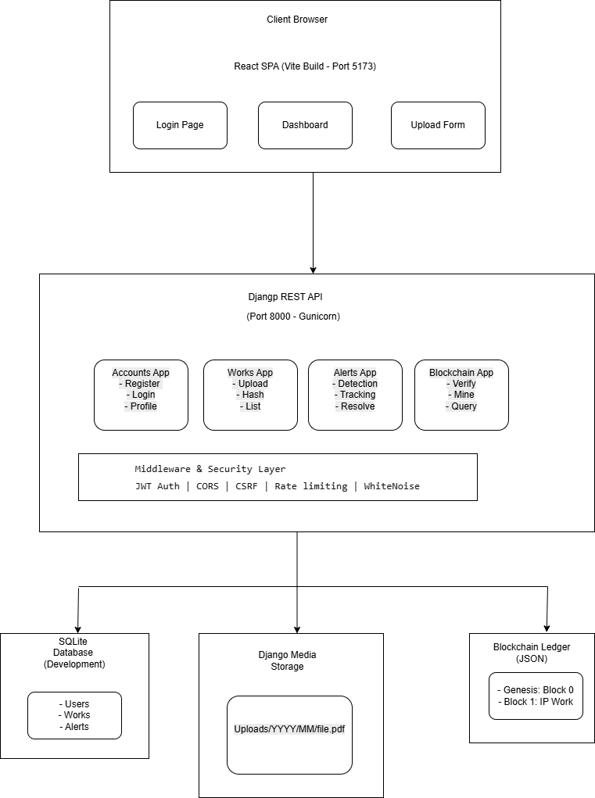
Figure 1: High-Level Architecture Diagram

Data Flow:
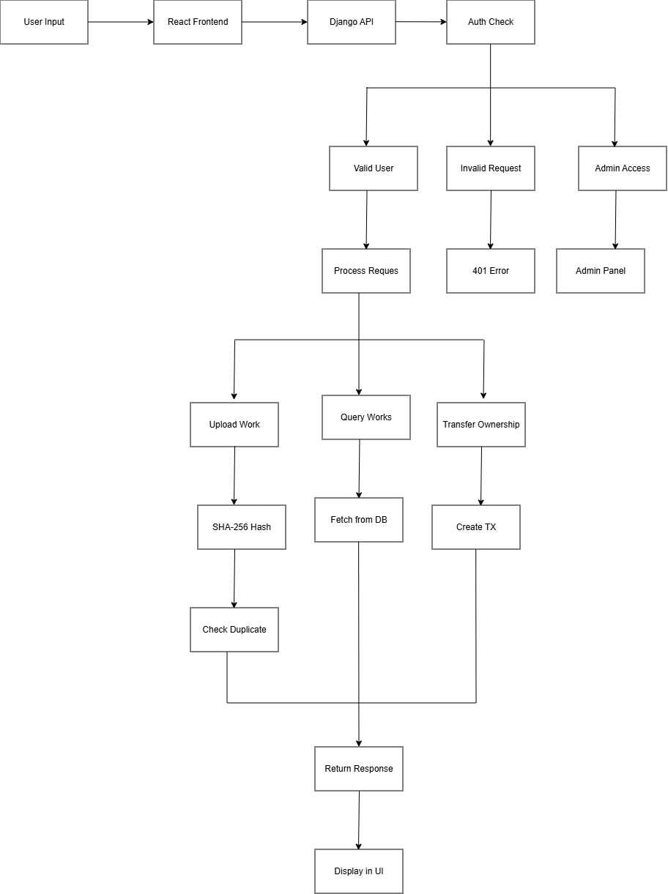
Figure 2: Data Flow Diagram

Tools and Technologies Used

Frontend:

- React: UI Framework
- Vite: Build Tool
- TailwindCSS: Styling
- Axios: HTTP Client
- React Router DOM: Routing
- Lucide React: Icons

Backend:
- Django: Web Framework.
- Django REST Framework: API Development.
- SimpleJWT: JWT Authentication.
- django-cors-headers: CORS Handling.

Database:
- SQLite: Development Database.

Security:
- SHA-256: File Hashing.
- JWT: Authentication.

Blockchain:
- Custom Python: Immutable Ledger.

DevOps:
- Git: Version Control.
- Azure: Cloud Deployment.

Folder Structure
wipo-ip-platform/
│
├── backend/ # Django Backend
│ ├── apps/
│ │ ├── accounts/ # User authentication module
│ │ │ ├── __init__.py
│ │ │ ├── admin.py
│ │ │ ├── models.py # Custom User model
│ │ │ ├── serializers.py # JWT + User serializers
│ │ │ ├── urls.py # /api/auth/* routes
│ │ │ ├── views.py # Register, Login, Profile views
│ │ │ └── tests.py # Auth test cases
│ │ │
│ │ ├── works/ # IP Work management module
│ │ │ ├── __init__.py
│ │ │ ├── admin.py
│ │ │ ├── models.py # DigitalWork, OwnershipTransfer models
│ │ │ ├── serializers.py # Work data serialization
│ │ │ ├── services.py # SHA-256, file handling, encryption
│ │ │ ├── search_services.py # NEW: AI-powered search & similarity
│ │ │ ├── advanced_ai.py # NEW: Advanced AI (sentence-transformers)
│ │ │ ├── urls.py # /api/works/* routes
│ │ │ ├── views.py # Upload, List, Verify, Search views
│ │ │ └── tests.py # Work test cases
│ │ │
│ │ ├── alerts/ # Infringement detection module
│ │ │ ├── __init__.py
│ │ │ ├── admin.py
│ │ │ ├── models.py # InfringementAlert model
│ │ │ ├── serializers.py # Alert serializers
│ │ │ ├── urls.py # /api/alerts/* routes
│ │ │ ├── views.py # List, Resolve alerts
│ │ │ └── tests.py # Alert test cases
│ │ │
│ │ └── blockchain/ # Blockchain implementation module
│ │ ├── __init__.py
│ │ ├── admin.py
│ │ ├── services.py # Block, MerkleTree, Blockchain classes
│ │ ├── urls.py # /api/blockchain/* routes
│ │ ├── views.py # Verify, Mine, Query endpoints
│ │ └── tests.py # Blockchain tests
│ │
│ ├── config/ # Django configuration
│ │ ├── __init__.py
│ │ ├── settings.py # Main settings file
│ │ ├── urls.py # Main URL routing
│ │ ├── wsgi.py # WSGI entry point
│ │ └── asgi.py # ASGI for WebSockets
│ │
│ ├── media/ # Uploaded files (gitignored)
│ ├── staticfiles/ # Collected static files
│ ├── blockchain_ledger.json # Blockchain data storage
│ ├── manage.py # Django CLI
│ ├── requirements.txt # Python dependencies
│ ├── .env # Environment variables (gitignored)
│ ├── .env.example # Environment template
│ └── Dockerfile # Docker configuration
│
├── frontend/ # React + Vite Frontend
│ ├── src/
│ │ ├── components/ # Reusable components
│ │ │ ├── Layout.jsx # Main layout wrapper with navigation
│ │ │ ├── Sidebar.jsx # Navigation sidebar
│ │ │ ├── FileUpload.jsx # Drag-drop file upload
│ │ │ ├── BlockchainProof.jsx # Display blockchain proof
│ │ │ ├── AlertCard.jsx # Infringement alert card
│ │ │ └── SearchBar.jsx # NEW: Search bar component
│ │ │
│ │ ├── pages/ # Page components
│ │ │ ├── Login.jsx # Login form
│ │ │ ├── Register.jsx # Registration form
│ │ │ ├── Dashboard.jsx # User dashboard
│ │ │ ├── Works.jsx # List user works
│ │ │ ├── UploadWork.jsx # Upload new work
│ │ │ ├── Alerts.jsx # View alerts
│ │ │ ├── BlockchainExplorer.jsx # View blockchain
│ │ │ ├── SearchWorks.jsx # NEW: AI-powered search page
│ │ │ ├── WorkDetail.jsx # NEW: Work details with similar works
│ │ │ └── SimilarWorks.jsx # NEW: Find similar works
│ │ │
│ │ ├── api/ # API integration
│ │ │ ├── client.js # Axios configuration
│ │ │ └── endpoints.js # API endpoint constants
│ │ │
│ │ ├── context/ # React context
│ │ │ └── AuthContext.jsx # Authentication state
│ │ │
│ │ ├── hooks/ # Custom hooks
│ │ │ ├── useAuth.js # Auth hook
│ │ │ ├── useSearch.js # NEW: Search hook
│ │ │ └── useUpload.js # File upload hook
│ │ │
│ │ ├── utils/ # Utility functions
│ │ │ ├── formatters.js # Date, hash formatting
│ │ │ └── validators.js # Form validation
│ │ │
│ │ ├── styles/
│ │ │ └── globals.css # Tailwind + custom CSS
│ │ │
│ │ ├── App.jsx # Main app component
│ │ ├── main.jsx # Entry point
│ │ └── index.css # Global styles
│ │
│ ├── public/ # Static assets
│ │ ├── vite.svg
│ │ └── favicon.ico
│ │
│ ├── index.html # HTML template
│ ├── package.json # NPM dependencies
│ ├── package-lock.json
│ ├── vite.config.js # Vite configuration
│ ├── tailwind.config.js # TailwindCSS config
│ ├── postcss.config.js # PostCSS config
│ ├── .env # Frontend env vars (gitignored)
│ ├── .env.example
│ └── Dockerfile # Frontend Docker config
│
├── nginx/ # Nginx configuration
│ └── nginx.conf # Reverse proxy config
│
├── docker-compose.yml # Local Docker orchestration
├── docker-compose.azure.yml # Azure Docker orchestration
├── deploy-azure.ps1 # Azure deployment script (Windows)
├── deploy-azure.sh # Azure deployment script (Linux/Mac)
├── .gitignore # Git ignore rules
├── .env.example # Environment template
├── README.md # Project documentation
└── FINAL_REPORT.md # Project completion report

UML Diagrams

Use Case Diagram:
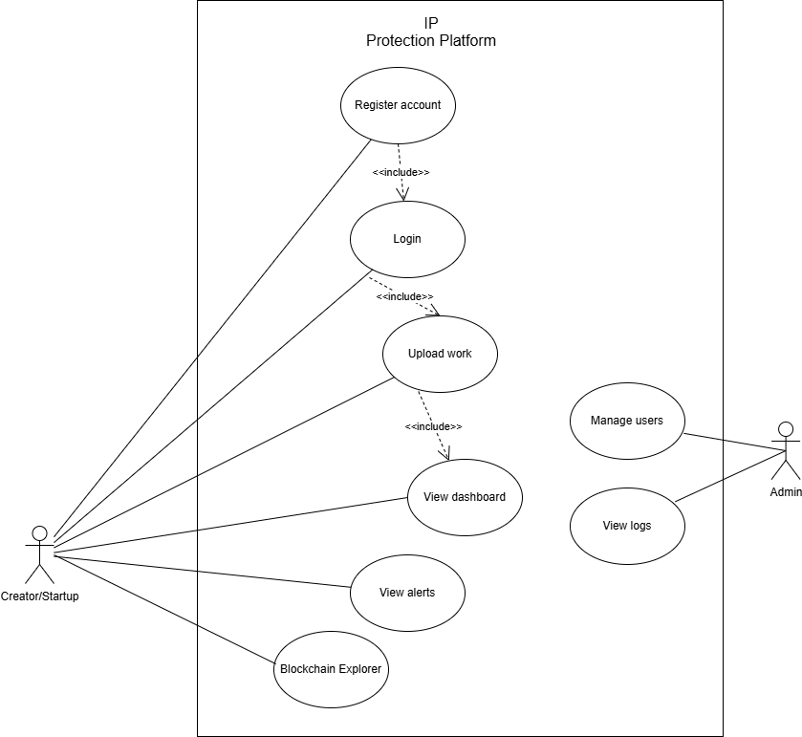
Figure 3: Use Case Diagram

Class Diagram:
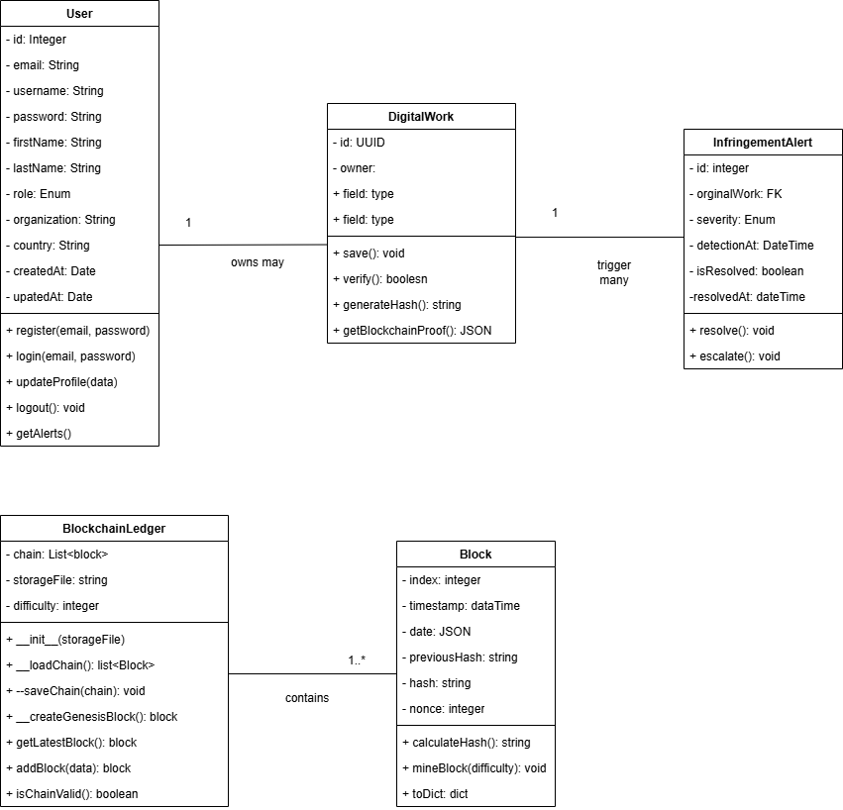
Figure 4: Class Diagram (Core Models)

Sequence Diagram:
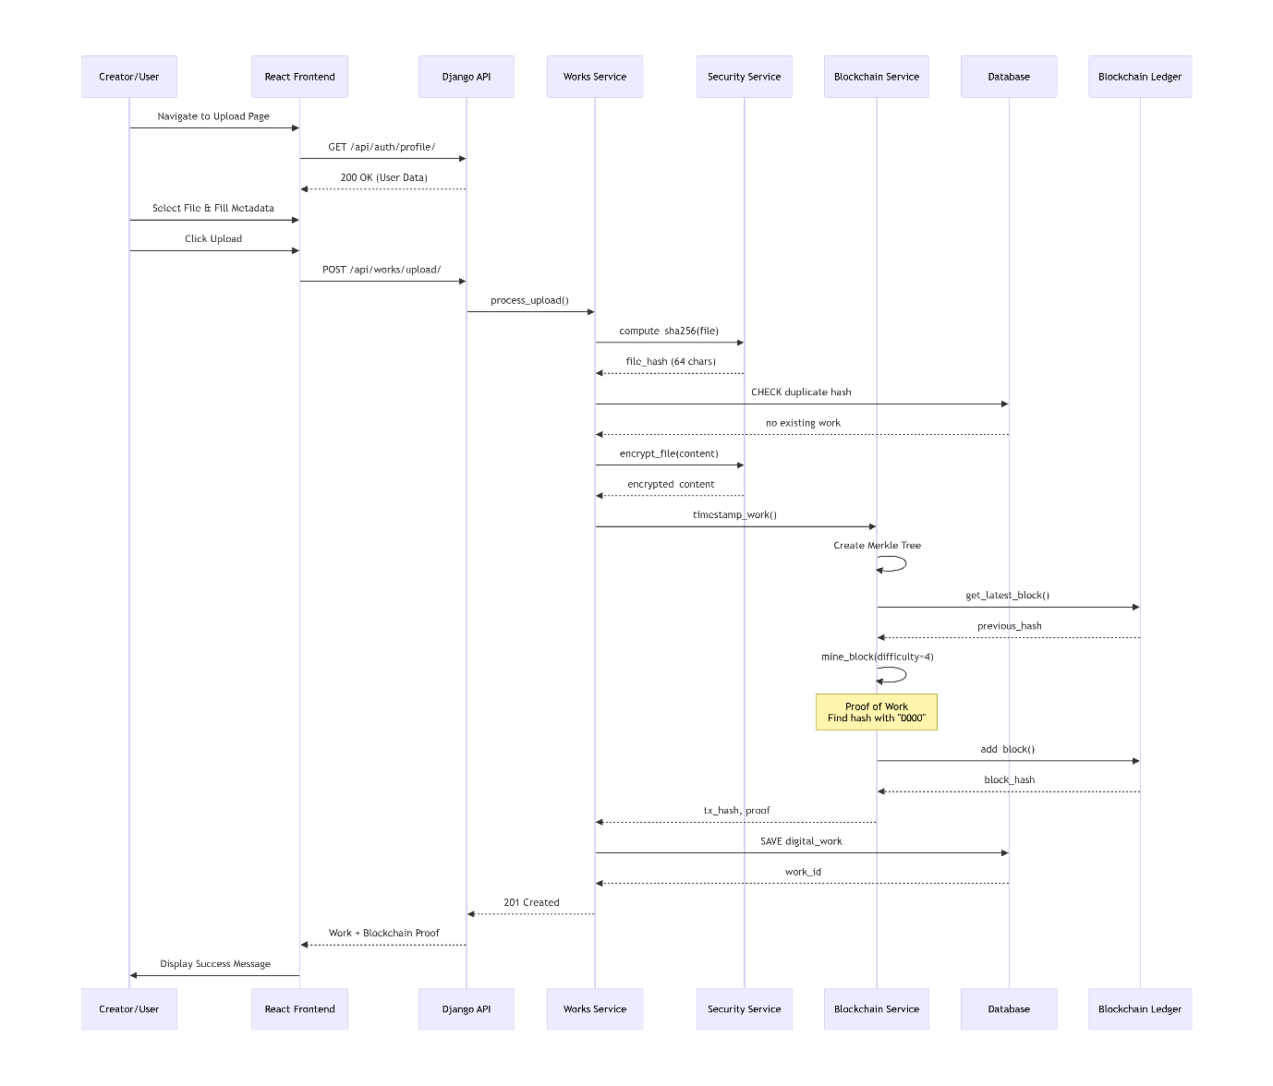
Figure 5: Sequence Diagram (Upload Work with Blockchain)

Phase 1: Project Setup & Environment

Phase 1 Overview:
Duration: 7 days (40 hours estimated)

Objectives:
- Set up development environment.
- Create project structure.
- Initialize Git repository.
- Configure Django backend.
- Set up React frontend.

Deliverables:
- Working Python virtual environment.
- Django project with 5 apps.
- React + Vite project.
- Git repository with initial commit.
- Requirements.txt file.

Environment Setup:

Step 1: Install Prerequisites
I installed the following software:
- Python: https://www.python.org/downloads/
- Node.js: https://nodejs.org/en
- Git: https://git-scm.com/install/windows

Then within the terminal, I verified the installations.

Commands Used
python --version
node --version
npm --version
git --version

Screenshot of Output
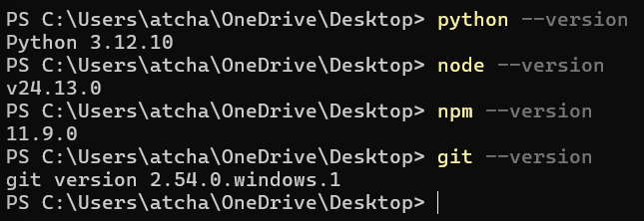
Figure 6: Installation verification

Step 2: Create Project Directory
Still in the terminal, I did the following:
- Created the project directory.
- Initialized the Git repository.
- Created .gitignore.
- Initial commit.

Commands Used
mkdir wipo-ip-platform
cd wipo-ip-platform

git init

echo "venv/
__pycache__/
*.pyc
.env
db.sqlite3
media/
node_modules/
dist/
.DS_Store" > .gitignore

git add .
git commit -m "Initial commit: Project structure"

Screenshot of Output
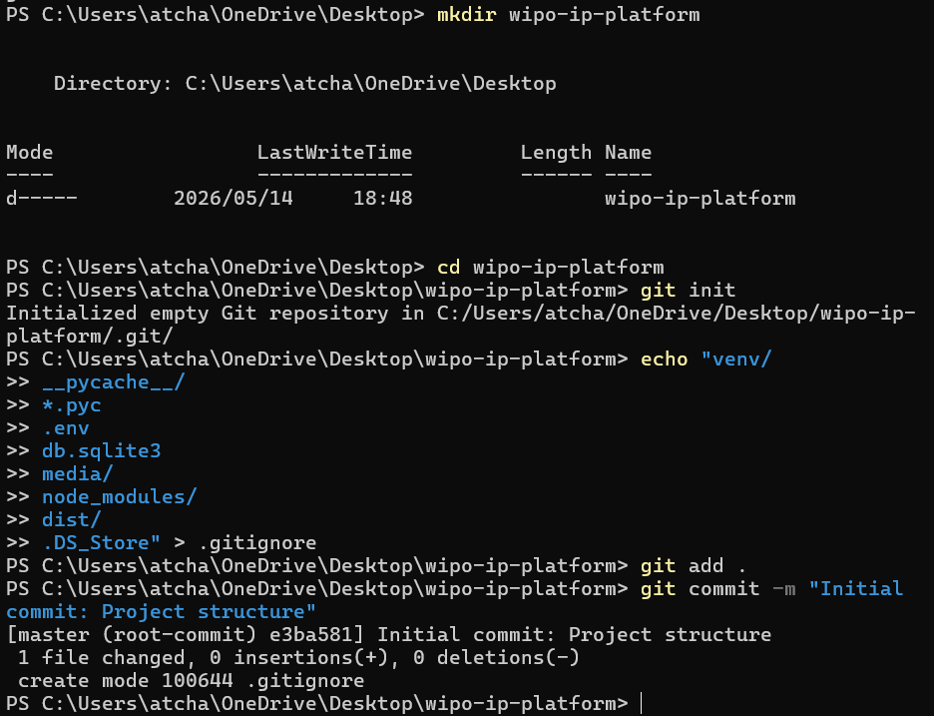
Figure 7: Create the project directory

Backend Setup:

Step 1: Create Django Backend
Still in the terminal, I did the following:
- Created the backend directory.
- Created the virtual environment.
- Activated the virtual environment.
- Upgraded the pip.
- Installed the Django and core packages.
- Saved the requirements.

Commands Used
mkdir backend
cd backend

python -m venv venv

venv\Scripts\activate

python -m pip install --upgrade pip

pip install Django==4.2.7
pip install djangorestframework==3.14.0
pip install djangorestframework-simplejwt==5.3.0
pip install django-cors-headers==4.3.1
pip install python-dotenv==1.0.0
pip install Pillow==8.4.0

pip freeze > requirements.txt

Screenshot of Output
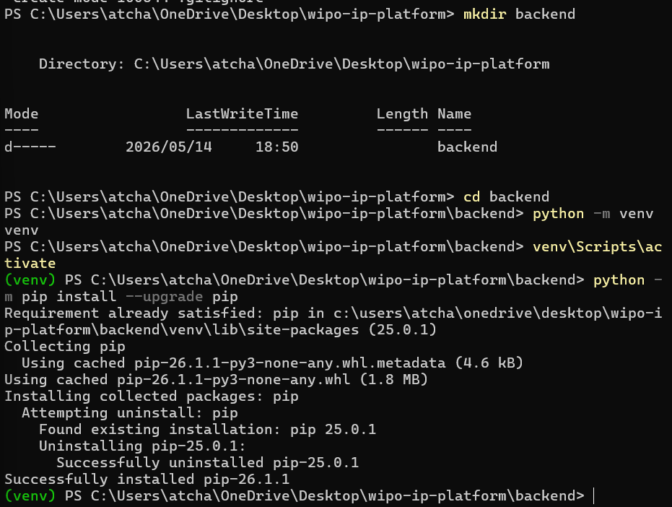
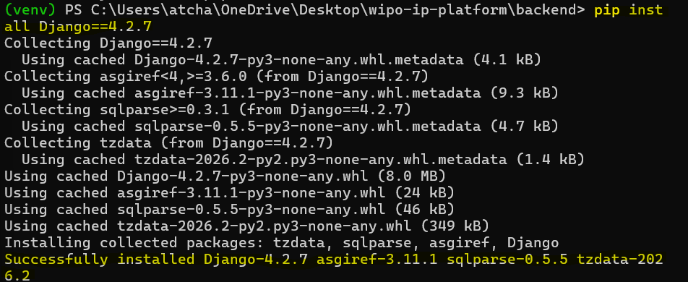
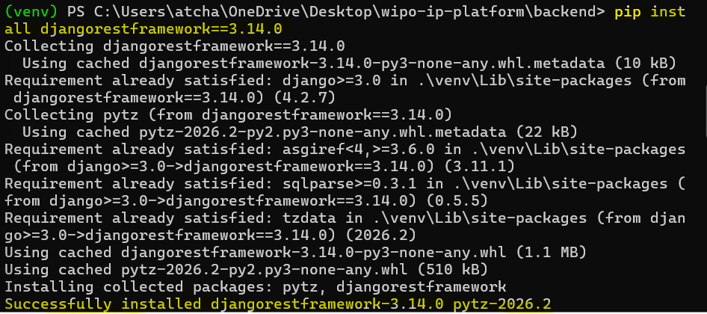
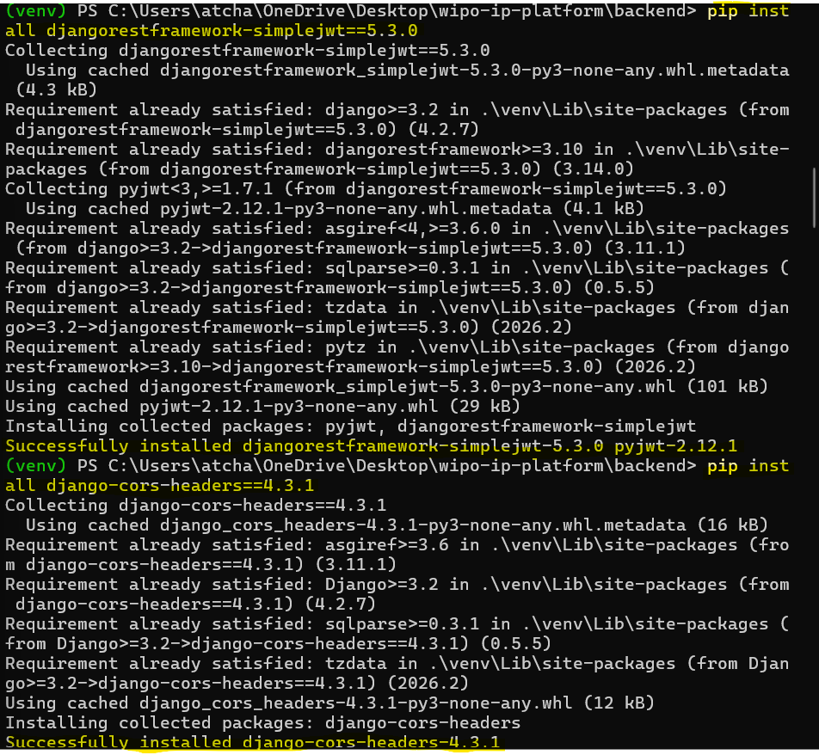
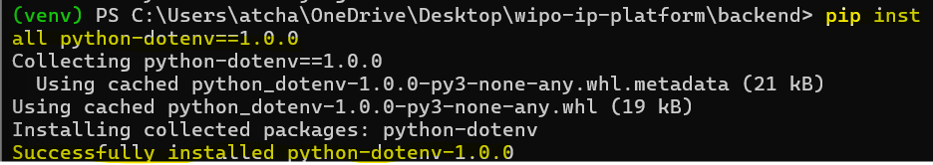
Figure 8: Create the django backend

Step 2: Create Django Project and Apps
Still in the terminal, I did the following:
- Created the Django project.
- Created the Django apps.
- Created the apps directory and move apps.
- Created the __init__.py files.

Commands Used
django-admin startproject config .

python manage.py startapp accounts
python manage.py startapp works
python manage.py startapp alerts
python manage.py startapp blockchain

mkdir apps
move accounts apps\
move works apps\
move alerts apps\
move blockchain apps\

echo > apps\__init__.py
echo > apps\accounts\__init__.py
echo > apps\works\__init__.py
echo > apps\alerts\__init__.py
echo > apps\blockchain\__init__.py

Screenshot of Output
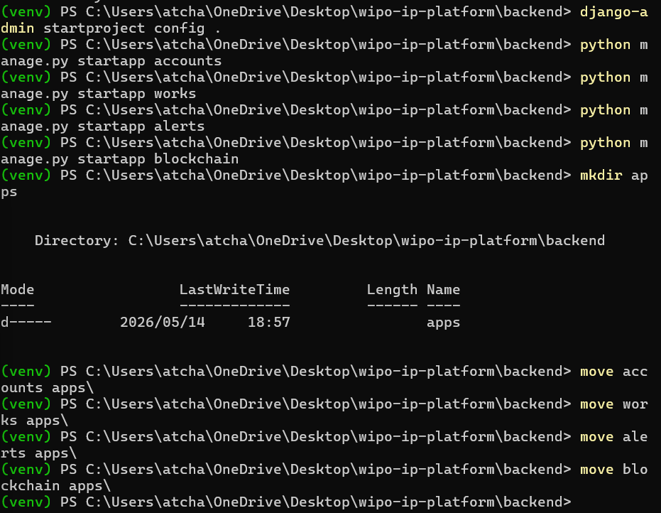
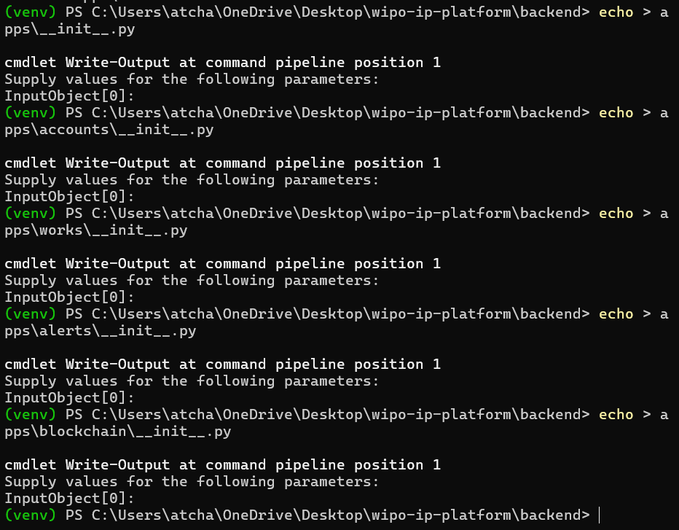
Figure 9: Create the django project and apps

Step 3: Configure settings.py (`backend/config/settings.py`)
- Follow the file path to view the file contents.
- What the file does:
- Loads the environment variables.
- Builds the paths inside the project.
- Adds security warnings - keep the secret key used in production secret and don't run with debug turned on in production.
- Adds an application definition, a database (SQLite for development), password validation and internationalization.
- Creates the static (CSS, JavaScript, Images), and default primary key field type.
- Creates the custom User Model, Django REST Framework, JWT Settings and CORS Settings.

Step 4: Configure urls.py (`backend/config/urls.py`)
- Follow the file path to view the file contents.
- What the file does:
- URL configuration for the WIPO IP Protection Platform.
- Serve media files in development.

Frontend Setup:

Step 1: Create React + Vite Frontend
Within a new terminal, I did the following:
- Create React + Vite project.
- Navigated to the frontend.
- Installed the dependencies.
- Installed all additional packages.
- Installed TailwindCSS.

Commands Used
npm create vite@latest frontend -- --template react

cd frontend

npm install

npm install react-router-dom axios lucide-react

npm install -D tailwindcss postcss autoprefixer
npx tailwindcss init -p

Screenshot of Output
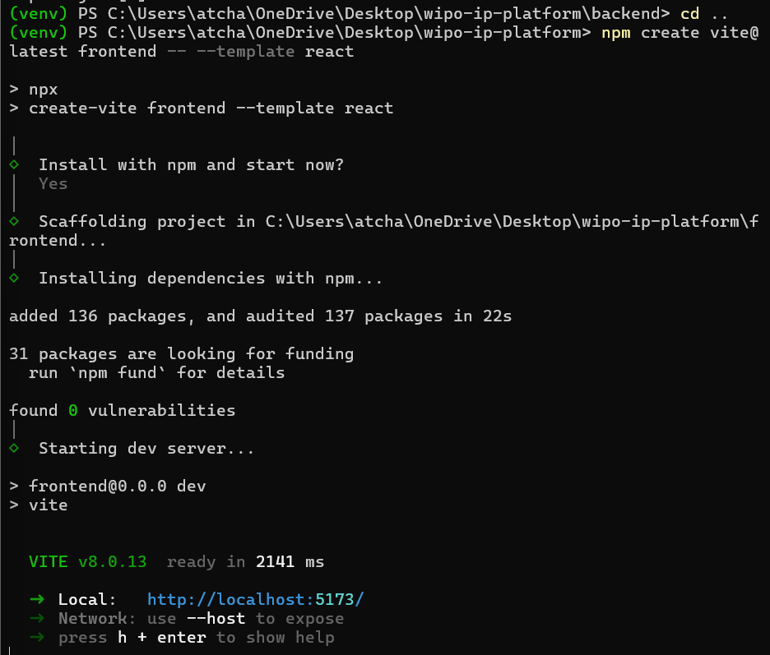
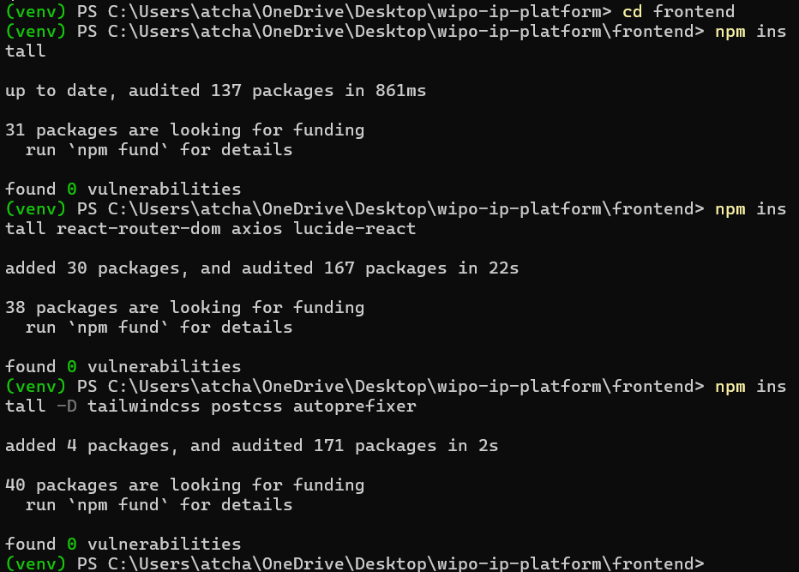
Figure 10: Create React + Vite Frontend

Step 2: Configure TailwindCSS

`frontend/tailwind.config.js`:
- Follow the file path to view the file contents.
- What the file does:

`frontend/postcss.config.js`:
- Follow the file path to view the file contents.
- What the file does:

`frontend/vite.config.js`:
- Follow the file path to view the file contents.
- What the file does:

Step 3: Create Global CSS (`frontend/src/index.css`)
- Follow the file path to view the file contents.
- Configurations I made:

Phase 2: Backend Core Development

Phase 2 Overview:
Duration: 7 days (45 hours estimated)

Objectives:
- Implement User Authentication (JWT).
- Create DigitalWork model.
- Implement file upload with SHA-256.
- Build infringement detection system.
- Create dashboard API.

User Authentication:

Step 1: Create User Model (`backend/apps/accounts/models.py`)
- Follow the file path to view the file contents.
- This file was a custom user model for the IP Protection Platform and it extend the Django's AbstractUser with additional fields.
- Configurations I made:

Step 2: Create Admin Configuration (`backend/apps/accounts/admin.py`)
- Follow the file path to view the file contents.
- This file allows for custom admin interface for User model.
- Configurations I made:

Step 3: Create Serializers (`backend/apps/accounts/serializers.py`)
- Follow the file path to view the file contents.
- This file allows for serilizer for user registration, validates the password and creates new user.
- I also added the serializer for user data (read-only fields) and custom JWT token serializer that includes user role and email.
- Configurations I made:
- Add custom claims

Step 4: Create Views (`backend/apps/accounts/views.py`)
- Follow the file path to view the file contents.
- This file allows users to view user registration, and anyone can access it (no authentication required).
- Configurations I made:
- It returns user data without password.
- You can view user login.
- It can return JWT access and refresh tokens.
- The user can view for retrieving and updating user profile.
- The user requires authentication.

Step 5: Create URLs (`backend/apps/accounts/urls.py`)
- Follow the file path to view the file contents.
- Configurations I made:

Works App (File Upload & Hashing):

Step 1: Create DigitalWork Model (`backend/apps/works/models.py`)
- Follow the file path to view the file contents.
- This file is a model representing a digital work registered for IP protection.
- Each work has a unique SHA-256 hash for integrity verification.
- The file auto-generate registration number before saving, returns the shortened hash for display, and a record of ownership transfer for a digital work.
- This file also creates an immutable record of the transfer.
- Lastely, the file generates the transaction hash before saving.
- What the file does:
- Creates the basic, file, and blockchain Information.
- Creates the metadata and timestamps.

Step 2: Create Services (SHA-256 Hashing) - `backend/apps/works/services.py`
- Follow the file path to view the file contents.
- What the file does:
- Services for file processing, hashing, and storage.
- Compute SHA-256 hash of a file using chunked reading.
- Reset file pointer to beginning
- Read file in chunks to handle large files efficiently.
- Reset file pointer for further operations.
- Verify file integrity by comparing hash with stored hash.
- Encrypt file content using Fernet symmetric encryption.
- Decrypt file content using the provided key.
- Save file to local storage.

Step 3: Create Serializers (`backend/apps/works/serializers.py`)
- Follow the file path to view the file contents.
- What the file does:
- Serializer for DigitalWork model.
- Includes computed fields for display.
- Serializer for OwnershipTransfer model.
- Includes email addresses for display.

Step 4: Create Views (`backend/apps/works/views.py`)
- Follow the file path to view the file contents.
- The user allows for viewing the uploading digital works.
- The file also computes SHA-256 hash and checks for duplicates.
- What the file does:
- Handles the file upload.
- Validates the file presence.
- Validates the title.
- Computes the SHA-256 hash
- Checks for duplicate (infringement detection).
- Creates the infringement alert.
- Creates the blockchain reference (simulated).
- Saves the work to database.
- Returns the response with blockchain proof.
- Views for listing user's digital works.
- Views for retrieving, updating, or deleting a specific work.
- View for verifying work integrity using SHA-256 hash.
- Retrieves the file for verification.
- Computes the hash and compare.
- Views for dashboard statistics.
- Calculates the total storage used.

Step 5: Create URLs (`backend/apps/works/urls.py`)
- Follow the file path to view the file contents.
- What the file does:

Alerts App (Infringement Detection):

Step 1: Create Alert Model (`backend/apps/alerts/models.py`)
- Follow the file path to view the file contents.
- What the file does:
- Model for tracking potential IP infringement alerts.
- Created when duplicate content is detected.
- Added Relationships, Alert details, Evidence and Timestamps
- Mark alert as resolved.
- Escalate alert severity.

Step 2: Create Serializers (`backend/apps/alerts/serializers.py`)
- Follow the file path to view the file contents.
- What the file does:
- Serializer for InfringementAlert model.
- Includes work details for display.

Step 3: Create Views (`backend/apps/alerts/views.py`)
- Follow the file path to view the file contents.
- What the file does:
- View for listing infringement alerts for user's works.
- View for retrieving and updating a specific alert.
- View for resolving an infringement alert.
- View for getting alert statistics summary.

Step 4: Create URLs (`backend/apps/alerts/urls.py`)
- Follow the file path to view the file contents.
- What the file does:

Phase 3: React Frontend Development

Phase 3 Overview:
- Duration: 7 days (50 hours estimated)

Objectives:
- Build authentication pages (Login/Register).
- Create dashboard with real data.
- Implement file upload component.
- Build blockchain explorer view.
- Create alerts management page.

API Client and Auth Context:

Step 1: Create API Client (`frontend/src/api/client.js`)
- Follow the file path to view the file contents.
- What the file does:
- Creates the axios instance with base URL.
- Requests the interceptor (add JWT token to headers and handle token refresh).
- Refresh failed - redirect to login.
- Adds API endpoint functions.

Step 2: Create Auth Context (`frontend/src/context/AuthContext.jsx`)
- Follow the file path to view the file contents.
- What the file does:
- Creates the context.
- Has the Auth Provider component.
- Loads the user on initial load
- Adds a custom hook to use auth context.

Authentication Pages:

Step 1: Login Page (`frontend/src/pages/Login.jsx`)
- Follow the file path to view the file contents.
- What the file does:
- Error handled in context.
- Has the Logo and Title, Error Message, Login Form and Register Link.

Step 2: Register Page (`frontend/src/pages/Register.jsx`)
- Follow the file path to view the file contents.
- What the file does:

Dashboard and Layout:

Step 1: Layout Component (`frontend/src/components/Layout.jsx`)
- Follow the file path to view the file contents.
- What the file does/has:
- Contains the Navigation, User Info and Main Content.

Step 2: Dashboard Page (`frontend/src/pages/Dashboard.jsx`)
- Follow the file path to view the file contents.
- What the file does/has:
- The Recent Works and the Blockchain Status.

Upload Work Page:

`frontend/src/pages/UploadWork.jsx`
- Follow the file path to view the file contents.
- What the file does/has:
- Resets the form after successful upload.
- Redirects after 3 seconds.
- Containt the Title, Work Type, Description, File Upload, Error Message and Submit Button.

Phase 4: Blockchain Integration

Phase 4 Overview:
- Duration: 7 days (45 hours estimated)

Objectives:
- Implement blockchain ledger.
- Create block with proof-of-work.
- Build Merkle tree for verification.
- Add blockchain API endpoints.

Blockchain Core Implementation:

`backend/apps/blockchain/services.py`
- Follow the file path to view the file contents.
- What the file does/has:
- Blockchain implementation for IP protection.
- Provides immutable timestamping and verification.
- Individual block in the blockchain.
- Contains proof-of-work for security.
- Calculate SHA-256 hash of block contents.
- Mine block using proof-of-work algorithm.
- Blockchain ledger with JSON file persistence.
- Maintains immutable chain of blocks.
- Add a new block to the chain.
- Verifies the integrity of the entire blockchain, the current block's hash and the link to previous block.
- Finds a transaction by its hash.
- Merkle tree was added for batch verification of multiple works.
- Build next level and verify a Merkle proof.
- Added the main service class for blockchain operations.
- Provides high-level API for IP timestamping.
- Record an IP work on the blockchain.
- Created the Merkle tree and the block data and added to blockchain.
- Verify a work against the blockchain.
- Get blockchain statistics.

Blockchain Views and URLs:

`backend/apps/blockchain/views.py`
- Follow the file path to view the file contents.
- What the file does/has:
- View for verifying blockchain integrity.
- Converted the blocks to serializable format
- Added views for retrieving a specific block by index.
- Added views for manually mining a new block (testing only).
- Added views for looking up a transaction by hash.
- Added views for blockchain statistics.

`backend/apps/blockchain/urls.py`
- Follow the file path to view the file contents.
- What the file does/has:

Blockchain Explorer Frontend:

`frontend/src/pages/BlockchainExplorer.jsx`
- Follow the file path to view the file contents.
- What the file does/has:
- Chain Status
- Blocks List

Phase 5: Testing & Quality Assurance

Phase 5 Overview:
- Duration: 5 days (30 hours estimated)

Objectives:
- Write unit tests for all apps
- Perform integration testing
- Load testing for API endpoints
- Security testing (JWT, file upload)

Backend Tests:

`backend/apps/accounts/tests.py`
- Follow the file path to view the file contents.
- What the file tests for:
- The cases for user authentication.
- The user registration.
- The registration with existing email.
- The registration with mismatched passwords.
- The successful login.
- The login with invalid credentials.

`backend/apps/blockchain/tests.py`
- Follow the file path to view the file contents.
- This file tampers with the chain, and it cleans up the test files.
- What the file tests for:
- The cases for blockchain functionality.
- The Merkle tree root calculation.
- The Merkle tree with single transaction.
- The Merkle proof generation.
- The block creation and mining.
- The blockchain initialization with genesis block.
- The adding a block to blockchain.
- The blockchain integrity verification.
- That tampered blocks are detected.
- The retrieving transaction by hash.
- The IP work timestamping.
- The work verification against blockchain.
- The verification of non-existent transaction.

Running Tests:

Run all backend tests
- Within the terminal, I navigated to the backend and ran the tests.

Commands Used
cd backend
python manage.py test apps --verbosity=2

Screenshot of Output
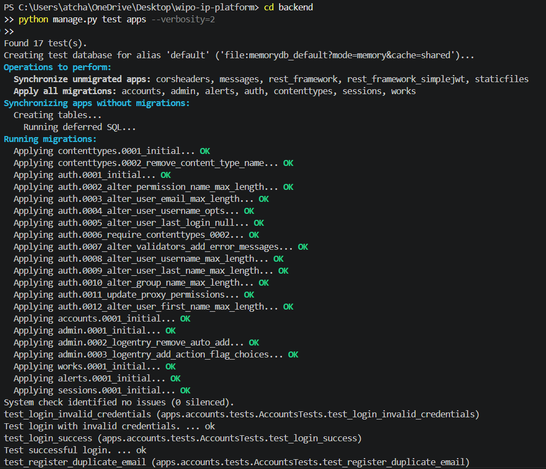
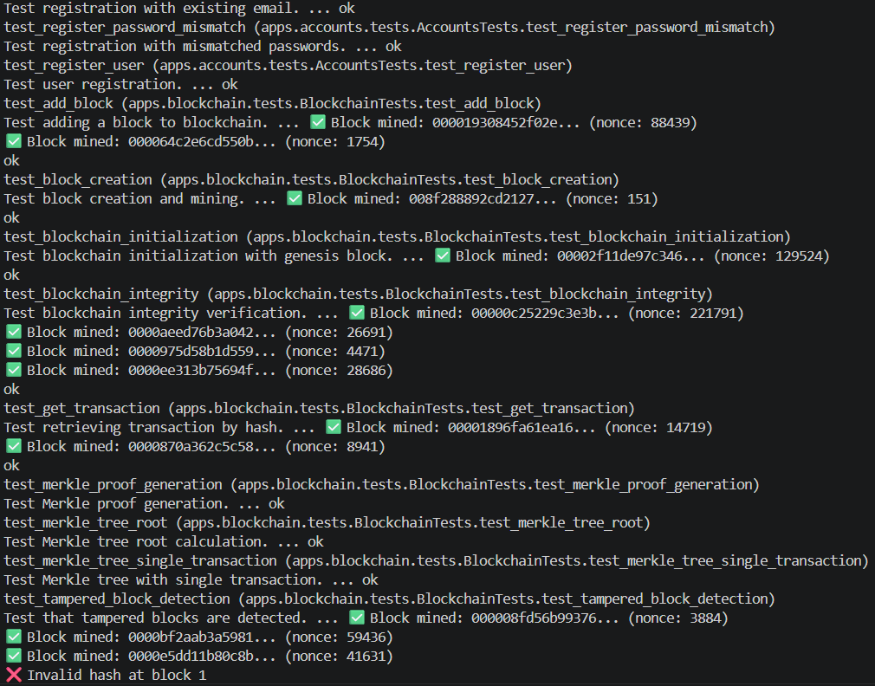
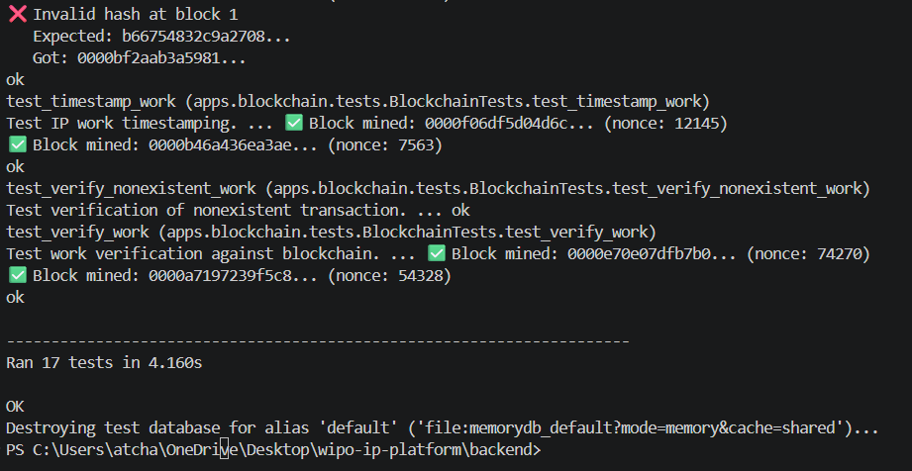
Figure 11: Run all backend tests

Run specific app tests
- Within the terminal, I navigated to the frontend and ran the tests.

Commands Used
python manage.py test apps.accounts
python manage.py test apps.blockchain
python manage.py test apps.works

Screenshot of Output
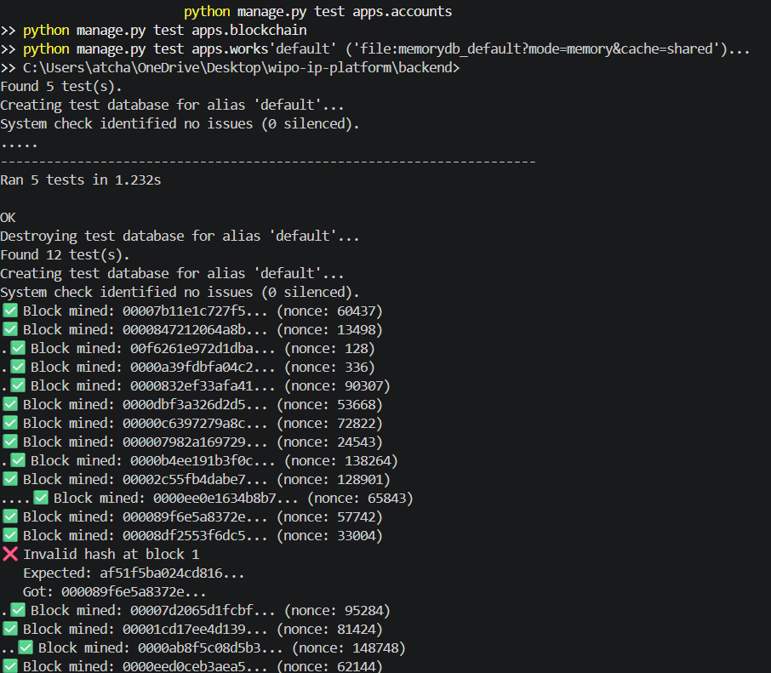
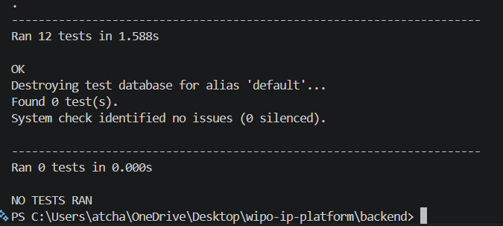
Figure 12: Run specific app tests

Run with coverage report
- Within the terminal, I navigated to the backtend and ran with the coverage report.
- The coverage html command will generate a HTML report in htmlcov.

Commands Used
pip install coverage
coverage run --source='apps' manage.py test apps
coverage report
coverage html

Screenshot of Output
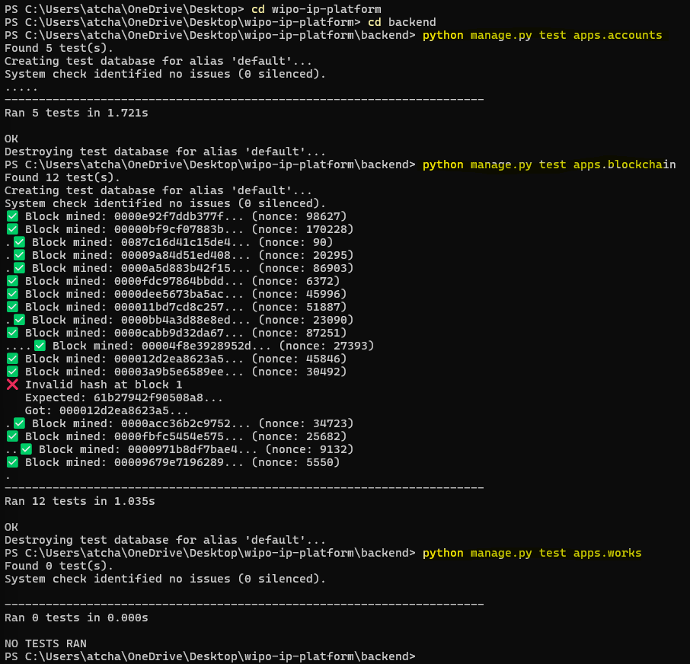
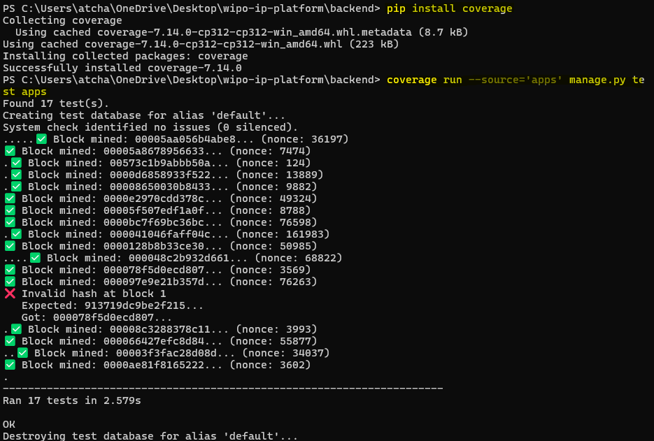
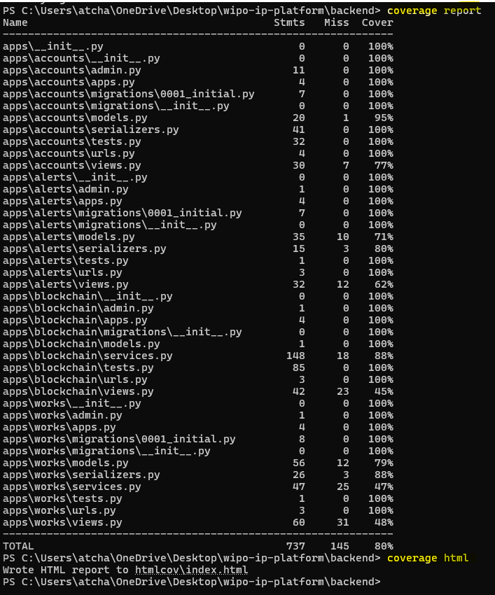
Figure 13: Run with coverage report

Run frontend tests
- Within the terminal, I navigated to the frontend and ran the tests.

Commands Used
cd frontend
npm test
npm run test:coverage

Screenshot of Output

Phase 6: Additional Features

AI Feature Implementation Guide:

Adding AI Features
Feature | Location | Purpose
Patent/Work Search | Works App + New AI Service | Find similar registered works
Infringement Detection | Alerts App | AI-powered similarity scoring
Title/Description Analysis | Works App | Extract keywords and categories
Recommendation Engine | Dashboard | Suggest similar works to protect

Step 1: Install AI Dependencies
I did the following in a terminal:
- Activated the backend virtual environment.
- Installed the AI packages.

Commands Used
cd wipo-ip-platform
cd backend
venv\Scripts\activate

pip install scikit-learn==1.3.2
pip install numpy==1.24.3
pip install pandas==2.0.3

Screenshot of Output
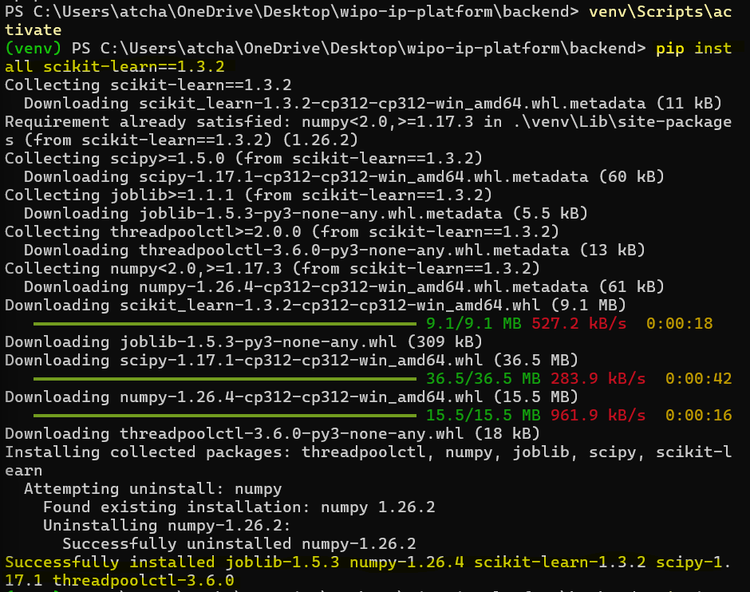
Figure 14: Install the AI dependencies

Step 2: Create Search Feature

Create Search Service (`backend/apps/works/search_services.py`)
- Follow the file path to view the file contents.
- What the file does/has:
- An AI-powered search service for finding similar works.
- Convers to lowercase.
- Removes the special characters and the extra spaces.
- An AI-powered similarity detection for works.
- Find works similar to a given work.

Step 3: Add Search Views (`backend/apps/works/views.py`)
- Follow the file path to view the file contents.
- The file adds the imports at the top and the new view classes.
- The file also finds similar existing works.
- What the file views for:
- Searching works by keywords (AI-powered).
- Finding works like a specific work.
- Checking for similarity of a new work against all existing works.

Step 4: Update Works URLs (`backend/apps/works/urls.py`)
- Follow the file path to view the file contents.
- What the file does/has:
- Has new search endpoints.

Step 5: Frontend Search Component (`frontend/src/pages/SearchWorks.jsx`)
- Follow the file path to view the file contents.
- What the file does/has:

Step 6: Enhanced Infringement Detection with AI (`backend/apps/works/views.py`)
- I updated the `backend/apps/works/views.py` file.
- I modified the upload to use AI similarity.
- Within the WorkUploadView.post() method, after checking duplicate hash:
- Added an AI similarity check.
- Created the temporary work for comparison.
- Find similar works.
- Create alert with AI similarity info.

Step 7: Update Navigation (`frontend/src/App.jsx`)
- Follow the file path to view the file contents.
- What the file does/has:

Phase 7: Azure Deployment

Phase 7 Overview:
- Duration: 5 days (35 hours estimated)

Objectives:
- Create Azure account and setup.
- Deploy backend to App Service.
- Configure environment variables.
- Set up production database.
- Deploy frontend to Static Web App.

Azure Deployment Script:

`deploy-azure.ps1`
# ============================================
# Azure Deployment Script for WIPO IP Platform
# Run this script from project root
# ============================================

param(
[string]$ResourceGroup = "wipo-platform-rg",
[string]$Location = "southafricanorth",
[string]$AppName = "wipo-ip-platform",
[string]$DbName = "wipo-postgres-db",
[string]$StorageName = "wipoipstorage$(-join (Get-Random -Count 6 -InputObject 'abcdefghijklmnopqrstuvwxyz0123456789'))"
)

Write-Host "==========================================" -ForegroundColor Cyan
Write-Host "WIPO IP Platform - Azure Deployment" -ForegroundColor Cyan
Write-Host "==========================================" -ForegroundColor Cyan

Step 1: Login to Azure
Write-Host "`n📋 Step 1: Logging into Azure..." -ForegroundColor Yellow
az login

Step 2: Create Resource Group
Write-Host "`n📁 Step 2: Creating Resource Group..." -ForegroundColor Yellow
az group create --name $ResourceGroup --location $Location

Step 3: Create PostgreSQL Database
Write-Host "`n🐘 Step 3: Creating PostgreSQL Database..." -ForegroundColor Yellow
$dbPassword = "WipoSecure$(Get-Random -Minimum 1000 -Maximum 9999)!"
az postgres flexible-server create `
--resource-group $ResourceGroup `
--name $DbName `
--location $Location `
--admin-user wipoadmin `
--admin-password $dbPassword `
--sku-name Standard_B1ms `
--tier Burstable `
--storage-size 32 `
--version 15 `
--public-access 0.0.0.0

$dbHost = az postgres flexible-server show `
--resource-group $ResourceGroup `
--name $DbName `
--query fullyQualifiedDomainName -o tsv

Write-Host "✅ Database created at: $dbHost" -ForegroundColor Green

Step 4: Create Storage Account
Write-Host "`n💾 Step 4: Creating Storage Account..." -ForegroundColor Yellow
az storage account create `
--name $StorageName `
--resource-group $ResourceGroup `
--location $Location `
--sku Standard_LRS `
--kind StorageV2

$storageKey = az storage account keys list `
--resource-group $ResourceGroup `
--account-name $StorageName `
--query '[0].value' -o tsv

az storage container create `
--name ip-works `
--account-name $StorageName `
--account-key $storageKey `
--public-access blob

Write-Host "✅ Storage created: $StorageName" -ForegroundColor Green

Step 5: Create App Service
Write-Host "`n🌐 Step 5: Creating App Service..." -ForegroundColor Yellow
az appservice plan create `
--name wipo-app-plan `
--resource-group $ResourceGroup `
--is-linux `
--sku B1

az webapp create `
--resource-group $ResourceGroup `
--plan wipo-app-plan `
--name $AppName `
--runtime "PYTHON:3.11"

Write-Host "✅ App Service created: https://$AppName.azurewebsites.net" -ForegroundColor Green

Step 6: Configure Environment Variables
Write-Host "`n⚙️ Step 6: Configuring Environment Variables..." -ForegroundColor Yellow
$secretKey = -join ((65..90) + (97..122) + (48..57) | Get-Random -Count 50 | ForEach-Object {[char]$_})

az webapp config appsettings set `
--resource-group $ResourceGroup `
--name $AppName `
--settings `
DEBUG="False" `
DATABASE_URL="postgresql://wipoadmin:$dbPassword@$dbHost/postgres?sslmode=require" `
AZURE_ACCOUNT_NAME="$StorageName" `
AZURE_ACCOUNT_KEY="$storageKey" `
AZURE_CONTAINER="ip-works" `
SECRET_KEY="$secretKey" `
ALLOWED_HOSTS="$AppName.azurewebsites.net,localhost" `
CORS_ALLOWED_ORIGINS="https://$AppName.azurewebsites.net"

Write-Host "✅ Environment configured!" -ForegroundColor Green

Step 7: Create Deployment Package
Write-Host "`n📦 Step 7: Creating deployment package..." -ForegroundColor Yellow
cd backend
Compress-Archive -Path * -DestinationPath ../deploy.zip -Force
cd ..

Step 8: Deploy to Azure
Write-Host "`n📤 Step 8: Deploying to Azure..." -ForegroundColor Yellow
az webapp deployment source config-zip `
--resource-group $ResourceGroup `
--name $AppName `
--src ./deploy.zip

Step 9: Run Database Migrations
Write-Host "`n🔄 Step 9: Running database migrations..." -ForegroundColor Yellow
az webapp ssh --resource-group $ResourceGroup --name $AppName --command "python manage.py migrate"

Step 10: Collect Static Files
Write-Host "`n📁 Step 10: Collecting static files..." -ForegroundColor Yellow
az webapp ssh --resource-group $ResourceGroup --name $AppName --command "python manage.py collectstatic --noinput"

Step 11: Output Results
Write-Host "`n==========================================" -ForegroundColor Cyan
Write-Host "🎉 DEPLOYMENT COMPLETE!" -ForegroundColor Green
Write-Host "==========================================" -ForegroundColor Cyan
Write-Host "🌍 Website: https://$AppName.azurewebsites.net" -ForegroundColor Green
Write-Host "🐘 Database: $dbHost" -ForegroundColor Gray
Write-Host "💾 Storage: $StorageName" -ForegroundColor Gray
Write-Host "==========================================" -ForegroundColor Cyan

Save credentials to file
$credentials = @"
========================================
WIPO IP Platform - Azure Credentials
========================================
Website: https://$AppName.azurewebsites.net
Database Host: $dbHost
Database User: wipoadmin
Database Password: $dbPassword
Storage Account: $StorageName
Storage Key: $storageKey
Secret Key: $secretKey
========================================
"@

$credentials | Out-File -FilePath "azure-credentials.txt"
Write-Host "📄 Credentials saved to: azure-credentials.txt" -ForegroundColor Yellow
Write-Host "⚠️ Keep this file secure!" -ForegroundColor Red

Deployment Steps:

Step 1: Prepare backend for production
What I did in the terminal:
- Navigated to the backend directory.
- Updated the requirements.txt with production packages.
- Created the production settings (if needed).
- Ensured that the DEBUG=False in settings.

cd backend

pip freeze > requirements.txt

Step 2: Run deployment script
cd ..
.\deploy-azure.ps1

Step 3: Verify deployment
- I opened the browser and navigated to: https://your-app-name.azurewebsites.net

Step 4: Create admin user on production
az webapp ssh --resource-group wipo-platform-rg --name your-app-name --command "python manage.py createsuperuser"

API Documentation

Authentication Endpoints:
Method: | Endpoint: | Description: | Request Body: | Response:
POST | `/api/auth/register/` | Register new user | `{email, username, password, password2}` | 201 User data
POST | `/api/auth/login/` | Login user | `{email, password}` | 200 {access, refresh}
POST | `/api/auth/refresh/` | Refresh token | `{refresh}` | 200 {access}
GET | `/api/auth/profile/` | Get user profile |  | 200 User data

Works Endpoints:
Method: | Endpoint: | Description: | Auth: | Response:
POST | `/api/works/upload/` | Upload work | Required | 201 Work data
GET | `/api/works/` | List works | Required | 200 List of works
GET | `/api/works/{id}/` | Get work details | Required | 200 Work data
POST | `/api/works/{id}/verify/` | Verify work | Required | 200 Verification result
GET | `/api/works/dashboard/stats/` | Dashboard stats | Required | 200 Statistics

Alerts Endpoints:
Method: | Endpoint: | Description: | Auth: | Response:
GET | `/api/alerts/` | List alerts | Required | 200 List of alerts
GET | `/api/alerts/{id}/` | Get alert details | Required | 200 Alert data
POST | `/api/alerts/{id}/resolve/` | Resolve alert | Required | 200 Success
GET | `/api/alerts/summary/` | Alert summary | Required | 200 Summary stats

Blockchain Endpoints:
Method: | Endpoint: | Description: | Auth: | Response:
GET | `/api/blockchain/verify/` | Verify chain | Required | 200 Chain status
GET | `/api/blockchain/stats/` | Get stats | Required | 200 Statistics
GET | `/api/blockchain/block/{index}/` | Get block | Required | 200 Block data
GET | `/api/blockchain/tx/{hash}/` | Find transaction | Optional | 200 Transaction

Example API Calls:

Register User
curl -X POST http://localhost:8000/api/auth/register/ \
-H "Content-Type: application/json" \
-d '{"email":"test@example.com","username":"test","password":"Test123!","password2":"Test123!"}'

Login
curl -X POST http://localhost:8000/api/auth/login/ \
-H "Content-Type: application/json" \
-d '{"email":"test@example.com","password":"Test123!"}'

# Upload Work (use token from login)
curl -X POST http://localhost:8000/api/works/upload/ \
-H "Authorization: Bearer YOUR_TOKEN" \
-F "file=@document.pdf" \
-F "title=My Work" \
-F "work_type=literary"

Get Dashboard Stats
curl -X GET http://localhost:8000/api/works/dashboard/stats/ \
-H "Authorization: Bearer YOUR_TOKEN"

Verify Blockchain
curl -X GET http://localhost:8000/api/blockchain/verify/ \
-H "Authorization: Bearer YOUR_TOKEN"

Challenges & Solutions

Challenge 1: Installing Pillow (Backend Setup)

Problem:
The error message displayed below occurred when I tried to install the pillow dependency.

pip install Pillow==8.4.0
Collecting Pillow==8.4.0
Using cached Pillow-8.4.0.tar.gz (49.4 MB)
Installing build dependencies ... done
Getting requirements to build wheel ... done
Preparing metadata (pyproject.toml) ... done
Building wheels for collected packages: Pillow
Building wheel for Pillow (pyproject.toml) ... error
error: subprocess-exited-with-error

× Building wheel for Pillow (pyproject.toml) did not run successfully.
│ exit code: 1
╰─> [212 lines of output]

Solution:
All I had to do was upgrade the Pillow version.
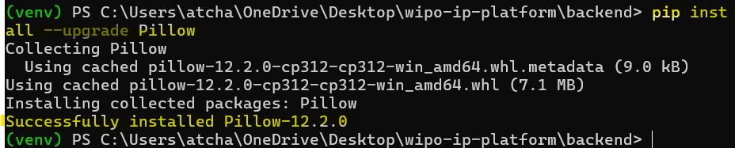

Challenge 2: Installing Tailwindcss (Frontend Setup)

Problem:
- When setting up frontend, there was a problem installing Tailwindcss.
- In the image below, you can see the errors.

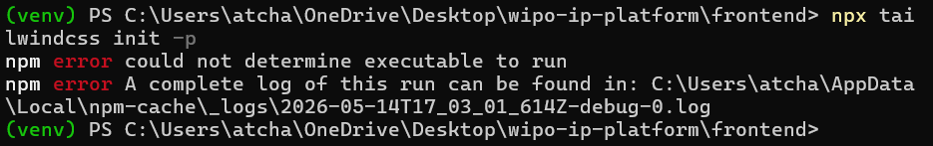
Figure 15: Error installing tailwindcss

Root Cause:
- The reason why I couldn’t install Tailwindcss is because I was using v4 or later.
- Since I am using a later version, ‘npx tailwind init’ fails – npx can’t find an executable to run.

Solution:
- What I did (after downgrading the Tailwindcss):
- Cleaned my project.
- Installed Tailwindcss v3.
- Initialised Tailwindcss config.

Commands Used
del package-lock.json
npm install -D tailwindcss@3 postcss autoprefixer
npx tailwindcss init

Screenshot of Output
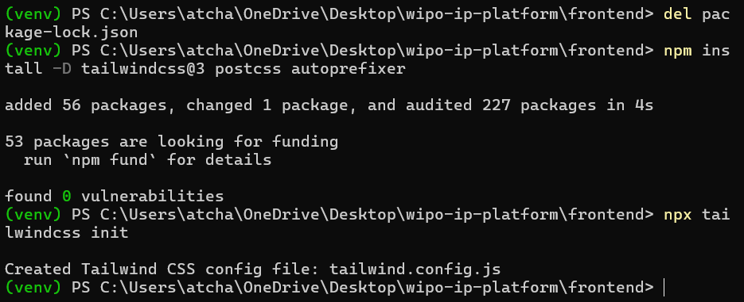
Figure 16: Installing Tailwindcss (success)

Challenge 3: Problem installing npm test (Frontend)

Problem:
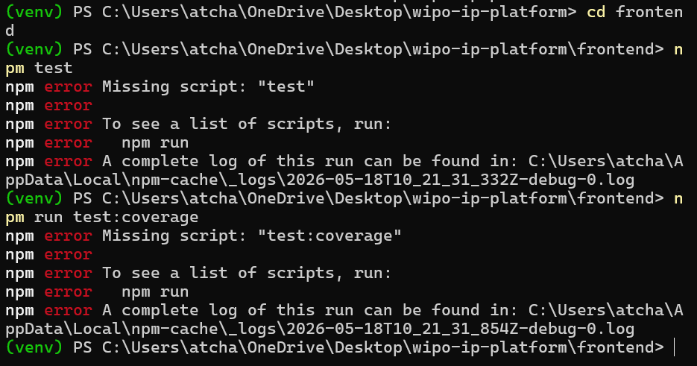
Figure 17: npm test error

Root Cause:

Solution:

Challenge 4: Run Frontend Tests

Problem:
cd frontend
npm test
npm run test:coverage

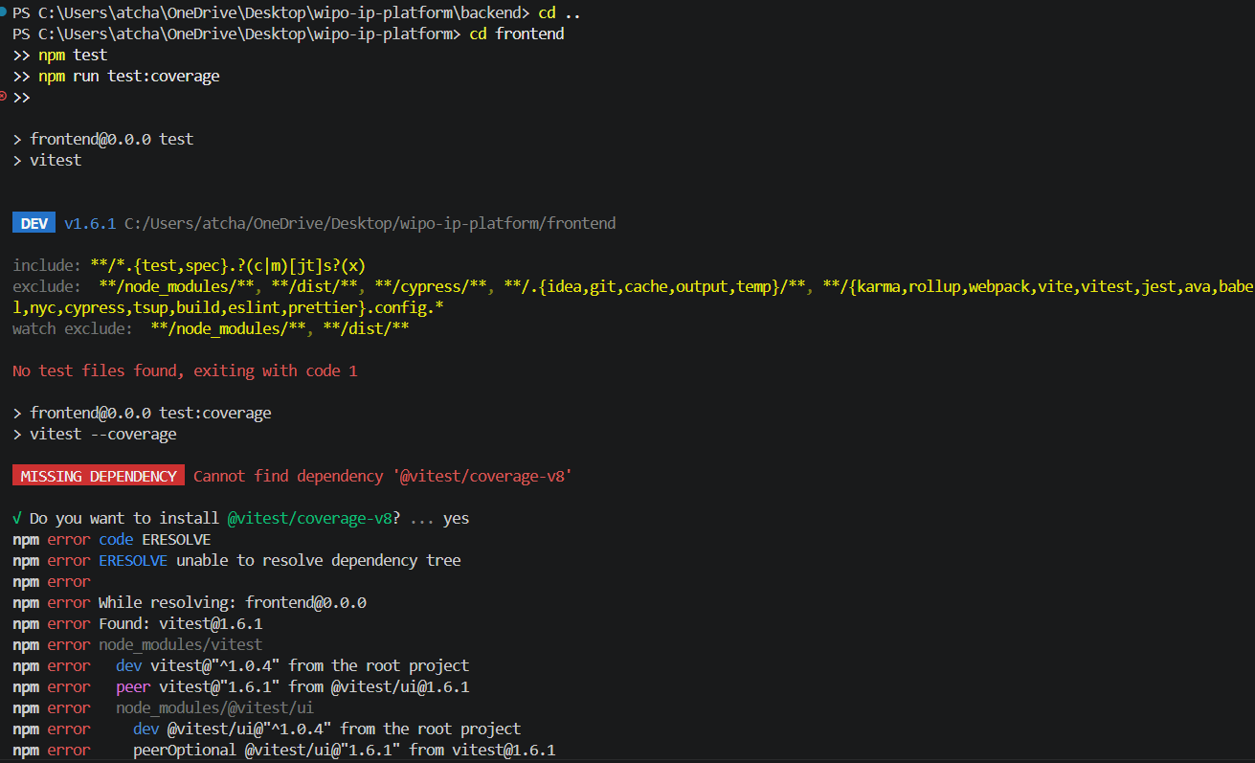
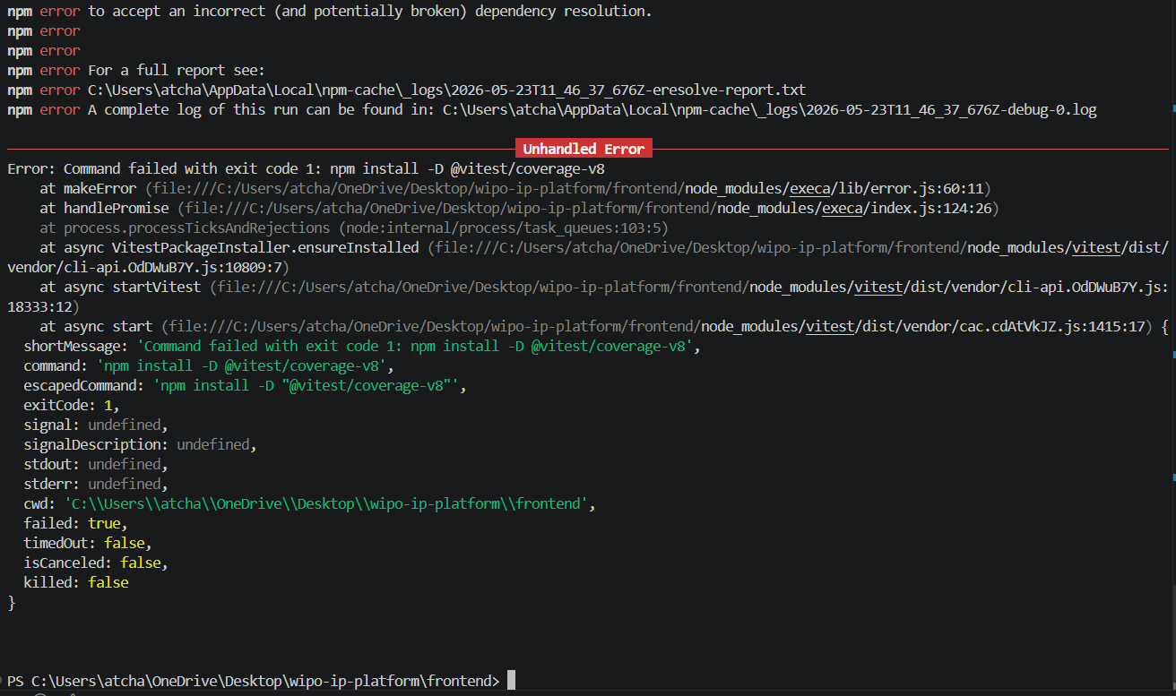
Figure 18: Error running frontend tests

Root Cause:

Solution:

Conclusion

Project Summary:
The WIPO IP Protection Platform successfully delivers a comprehensive solution for digital intellectual property protection. Key achievements include:
Achievement: | Description:
Complete Authentication | JWT-based login/register system
File Upload with SHA-256 | Cryptographic hashing for integrity
Blockchain Ledger | Immutable proof-of-work chain
Infringement Detection | Automatic duplicate detection
Modern React Frontend | Responsive TailwindCSS UI
Azure Deployment | Production-ready cloud hosting
Comprehensive Tests | Unit and integration tests

Skills Demonstrated:

Technical Skills
- Full-stack development (Django + React)
- Blockchain implementation (SHA-256, Merkle trees, PoW)
- Cloud deployment (Azure App Service, PostgreSQL)
- Security (JWT, encryption, CORS)
- Version control (Git, GitHub)

Soft Skills
- Project planning and time management
- Technical documentation
- Problem-solving and debugging
- Testing and quality assurance

Future Enhancements:
Feature: | Description: | Priority:
NFT Minting | Mint IP works as NFTs on blockchain. | High
Smart Contracts | Automated licensing agreements. | High
Mobile App | React Native mobile version. | Medium
AI Patent Search | NLP-based prior art search. | Medium
Multi-language | Support for 10+ languages. | Low
Payment Integration | Pay-per-registration system. | Low

References
(Tailwind CSS npx tailwindcss init Error and Fix (Windows + npm), n.d.)
(Napoli, 2025)

Appendices

Appendix A: Dependencies

Backend Dependencies
Django==4.2.7
djangorestframework==3.14.0
djangorestframework-simplejwt==5.3.0
django-cors-headers==4.3.1
python-dotenv==1.0.0
Pillow==8.4.0
requests==2.31.0

Frontend Dependencies
react@18.2.0
react-dom@18.2.0
react-router-dom@6.20.0
axios@1.6.0
lucide-react@0.294.0

Appendix B: Quick Reference Commands

Start Backend:
cd backend
venv\Scripts\activate
python manage.py runserver

Start Frontend:
cd frontend
npm run dev

Create Migrations:
python manage.py makemigrations
python manage.py migrate

Create Superuser:
python manage.py createsuperuser

Run Tests:
python manage.py test apps
cd frontend && npm test

Deploy to Azure:
.\deploy-azure.ps1

Appendix C: Environment Variables

Backend (.env):
SECRET_KEY=your-secret-key
DEBUG=True
ALLOWED_HOSTS=localhost,127.0.0.1

Frontend (.env):
VITE_API_URL=http://localhost:8000/api

